TASK 01:
#include <iostream>
using namespace std;

class Node
{
public:
int data;
Node *next;

Node(int val)
{
data = val;
next = nullptr;
}
};

class SLL
{
Node *head;
Node *tail;

public:
SLL()
{
head = tail = nullptr;
}

void insertFront(int val)
{
Node *newNode = new Node(val);

if (head == nullptr)
{
head = newNode;
tail = newNode;
return;
}

newNode->next = head;
head = newNode;
}

void insertBack(int val)
{
Node *newNode = new Node(val);

if (head == nullptr)
{
head = newNode;
tail = newNode;

return;
}

tail->next = newNode;
tail = newNode;
}

void insertPos(int pos, int val)
{
if (pos == 1)
{
insertFront(val);
return;
}

Node *newNode = new Node(val);

Node *temp;
temp = head;

for (int i = 1; i < pos - 1; i++)
{
if (temp == nullptr)
{
cout << "\nInvalid position. ";
delete newNode;
return;
}
temp = temp->next;
}

if (temp == nullptr)
{
cout << "\nInvalid position. ";
delete newNode;
return;
}

newNode->next = temp->next;
temp->next = newNode;

if (newNode->next == nullptr)
{
tail = newNode;
}
}

void removeFront()
{
if (head == nullptr)
{
return;
}

Node *temp;
temp = head;
head = head->next;
delete temp;

if (head == nullptr)
{
tail = nullptr;
}
}

void removeBack()
{
if (head == nullptr)
{
return;
}

if (head->next == nullptr)
{
delete head;
head = nullptr;
return;
}

Node *temp = head;
while (temp->next != tail)
{
temp = temp->next;
}

delete temp->next;
temp->next = nullptr;
tail = temp;
}

void deletePos(int pos)
{
if (head == nullptr)
{
cout << "\nList is empty. ";
return;
}

if (pos == 1)
{
removeFront();
return;
}

Node *temp;
temp = head;

for (int i = 1; i < pos - 1; i++)
{
if (temp->next == nullptr)
{
cout << "\nInvalid position. ";
return;
}

temp = temp->next;
}

Node *deletenode = temp->next;

if (deletenode == nullptr)
{
cout << "\nInvalid position.";
return;
}

if (deletenode == tail)
{
tail = temp;
}

temp->next = deletenode->next;

delete deletenode;
}

void display()
{
Node *temp = head;

cout << "\nList: ";

while (temp != nullptr)
{
cout << temp->data << " -> ";
temp = temp->next;
}

cout << "NULL";

if (head != nullptr)
{
cout << "\nHead = " << head->data;
cout << "\nTail = " << tail->data;
}
else
{
cout << "\nHead = NULL";
cout << "\nTail = NULL";
}

cout << endl;
}
};

int main()
{
SLL list;
int n;

cout << "\nEnter number of values to be stored in linked list: ";
cin >> n;

for (int i = 1; i <= n; i++)
{
int val, choice;

cout << "\nEnter value " << i << ": ";
cin >> val;

cout << "1. Insert at Front";
cout << "\n2. Insert at Back";
cout << "\nEnter choice: ";
cin >> choice;

if (choice == 1)
{
list.insertFront(val);
}
else if (choice == 2)
{
list.insertBack(val);
}
else
{
cout << "Invalid choice. Value not inserted.\n";
i--;
}
}

cout << "\n\n===== INITIAL LIST =====";
list.display();

int choice;

do
{
cout << "\n\n===== MENU =====";
cout << "\n1. Remove Front";
cout << "\n2. Remove Back";
cout << "\n3. Insert at Position";
cout << "\n4. Delete at Position";
cout << "\n5. Display List";
cout << "\n0. Exit";

cout << "\n\nEnter choice: ";
cin >> choice;

if (choice == 1)
{
list.removeFront();
cout << "\nAfter removing front:";
list.display();
}

else if (choice == 2)
{
list.removeBack();
cout << "\nAfter removing back:";
list.display();
}

else if (choice == 3)
{
int pos, val;

cout << "\nEnter position: ";
cin >> pos;

cout << "Enter value: ";
cin >> val;

list.insertPos(pos, val);

cout << "\nAfter insertion:";
list.display();
}

else if (choice == 4)
{
int pos;

cout << "\nEnter position to delete: ";
cin >> pos;

list.deletePos(pos);

cout << "\nAfter deletion:";
list.display();
}

else if (choice == 5)
{
list.display();
}

else if (choice == 0)
{
cout << "\nProgram ended.";
}

else
{
cout << "\nInvalid choice.";
}

} while (choice != 0);

return 0;
}
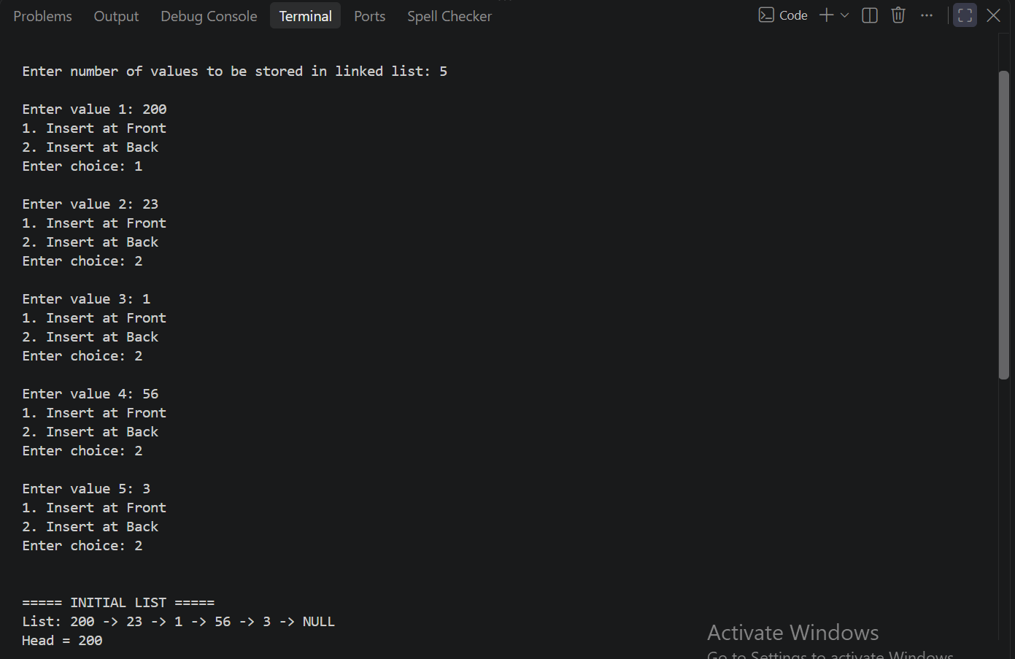
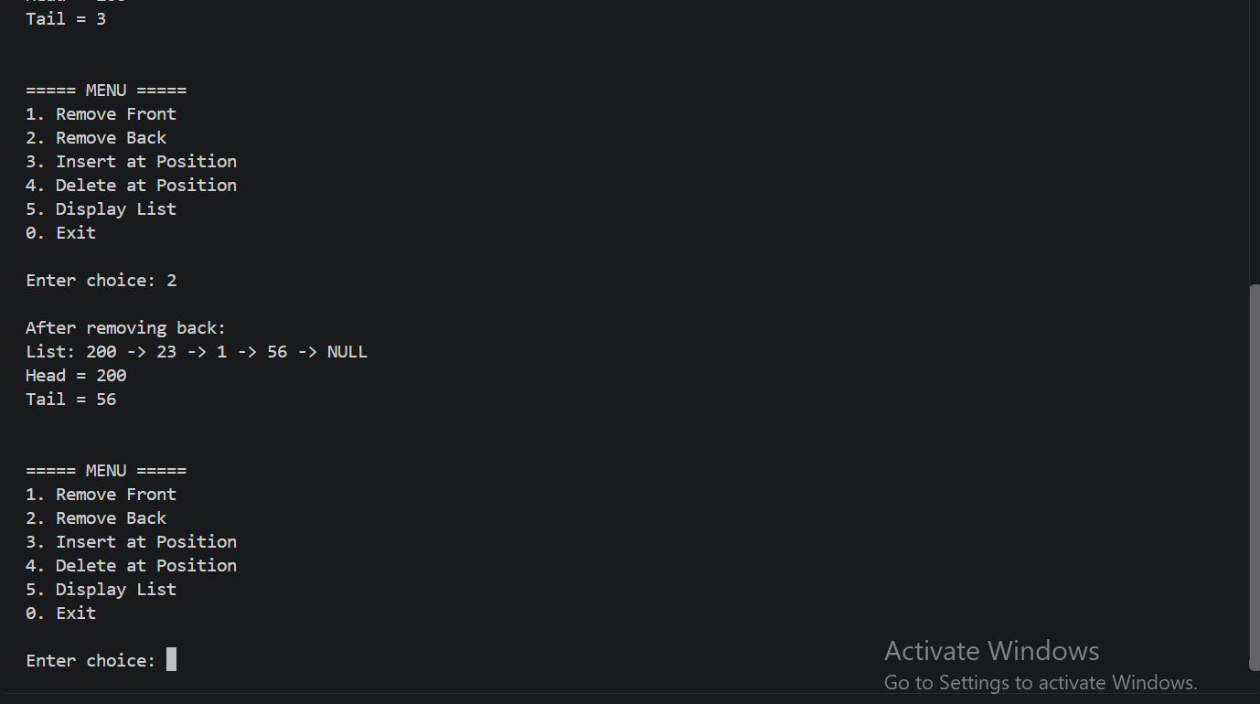

TASK 02:
#include <iostream>
using namespace std;

class Node
{
public:
int data;
Node *next;

Node(int val)
{
data = val;
next = nullptr;
}
};

class SLL
{
Node *head;
Node *tail;

public:
SLL()
{
head = tail = nullptr;
}

void insertFront(int val)
{
Node *newNode = new Node(val);

if (head == nullptr)
{
head = newNode;
tail = newNode;
return;
}

newNode->next = head;
head = newNode;
}

void insertBack(int val)
{
Node *newNode = new Node(val);

if (head == nullptr)
{
head = newNode;
tail = newNode;

return;
}

tail->next = newNode;
tail = newNode;
}

void insertPos(int pos, int val)
{
if (pos == 1)
{
insertFront(val);
return;
}

Node *newNode = new Node(val);

Node *temp;
temp = head;

for (int i = 1; i < pos - 1; i++)
{
if (temp == nullptr)
{
cout << "\nInvalid position. ";
delete newNode;
return;
}
temp = temp->next;
}

if (temp == nullptr)
{
cout << "\nInvalid position. ";
delete newNode;
return;
}

newNode->next = temp->next;
temp->next = newNode;

if (newNode->next == nullptr)
{
tail = newNode;
}
}

void removeFront()
{
if (head == nullptr)
{
return;
}

Node *temp;
temp = head;
head = head->next;
delete temp;

if (head == nullptr)
{
tail = nullptr;
}
}

void removeBack()
{
if (head == nullptr)
{
return;
}

if (head->next == nullptr)
{
delete head;
head = nullptr;
return;
}

Node *temp = head;
while (temp->next != tail)
{
temp = temp->next;
}

delete temp->next;
temp->next = nullptr;
tail = temp;
}

void deletePos(int pos)
{
if (head == nullptr)
{
cout << "\nList is empty. ";
return;
}

if (pos == 1)
{
removeFront();
return;
}

Node *temp;
temp = head;

for (int i = 1; i < pos - 1; i++)
{
if (temp->next == nullptr)
{
cout << "\nInvalid position. ";
return;
}

temp = temp->next;
}

Node *deletenode = temp->next;

if (deletenode == nullptr)
{
cout << "\nInvalid position.";
return;
}

if (deletenode == tail)
{
tail = temp;
}

temp->next = deletenode->next;

delete deletenode;
}

void display()
{
Node *temp = head;

cout << "\nList: ";

while (temp != nullptr)
{
cout << temp->data << " -> ";
temp = temp->next;
}

cout << "NULL";

if (head != nullptr)
{
cout << "\nHead = " << head->data;
cout << "\nTail = " << tail->data;
}
else
{
cout << "\nHead = NULL";
cout << "\nTail = NULL";
}

cout << endl;
}

void removeDuplicates()
{
Node *temp;
temp = head;

while (temp != nullptr && temp->next != nullptr)
{
Node *nodeToDel;
if (temp->data == temp->next->data)
{
nodeToDel = temp->next;
temp->next = nodeToDel->next;

if (nodeToDel == tail)
{
tail = temp;
}

delete nodeToDel;
}
else
{
temp = temp->next;
}
}
}
};

int main()
{
SLL list;
int n;

cout << "\nEnter number of values to be stored in linked list: ";
cin >> n;

for (int i = 1; i <= n; i++)
{
int val, choice;

cout << "\nEnter value " << i << ": ";
cin >> val;

cout << "1. Insert at Front";
cout << "\n2. Insert at Back";
cout << "\nEnter choice: ";
cin >> choice;

if (choice == 1)
{
list.insertFront(val);
}
else if (choice == 2)
{
list.insertBack(val);
}
else
{
cout << "Invalid choice. Value not inserted.\n";
i--;
}
}

cout << "\n\n===== INITIAL LIST =====";
list.display();

int choice;

do
{
cout << "\n\n===== MENU =====";
cout << "\n1. Remove Front";
cout << "\n2. Remove Back";
cout << "\n3. Insert at Position";
cout << "\n4. Delete at Position";
cout << "\n5. Display List";
cout << "\n6. Display List after removing duplicates";
cout << "\n0. Exit";

cout << "\n\nEnter choice: ";
cin >> choice;

if (choice == 1)
{
list.removeFront();
cout << "\nAfter removing front:";
list.display();
}

else if (choice == 2)
{
list.removeBack();
cout << "\nAfter removing back:";
list.display();
}

else if (choice == 3)
{
int pos, val;

cout << "\nEnter position: ";
cin >> pos;

cout << "Enter value: ";
cin >> val;

list.insertPos(pos, val);

cout << "\nAfter insertion:";
list.display();
}

else if (choice == 4)
{
int pos;

cout << "\nEnter position to delete: ";
cin >> pos;

list.deletePos(pos);

cout << "\nAfter deletion:";
list.display();
}

else if (choice == 5)
{
list.display();
}

else if(choice==6)
{
cout<<"\nLIST AFTER REMOVING DUPLICATES(If Any): ";
list.removeDuplicates();
list.display();
}

else if (choice == 0)
{
cout << "\nProgram ended.";
}

else
{
cout << "\nInvalid choice.";
}

} while (choice != 0);

return 0;
}
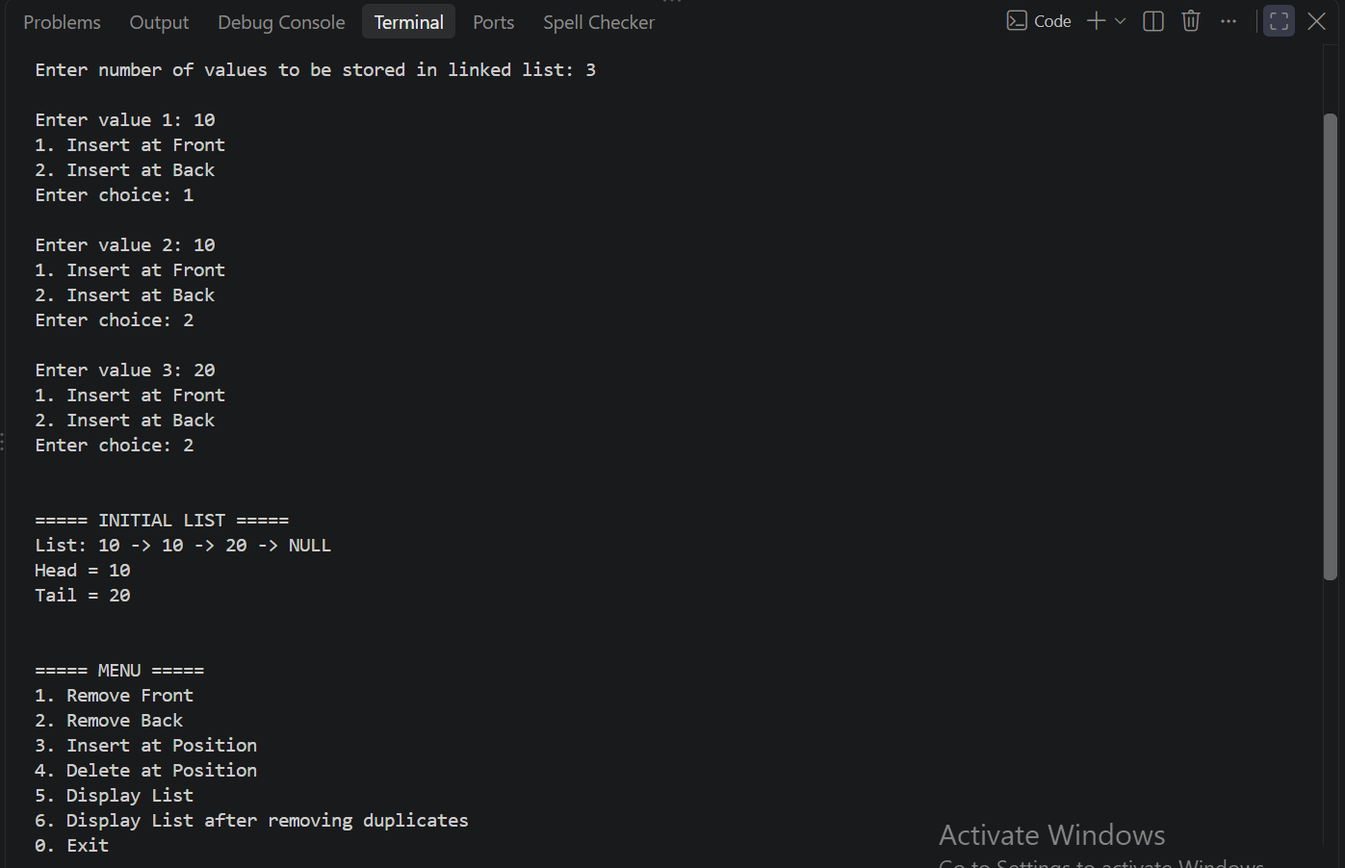
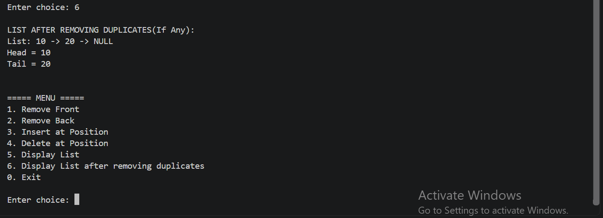

TASK 03:
#include <iostream>
using namespace std;

class Node
{
public:
int data;
Node *next;

Node(int val)
{
data = val;
next = nullptr;
}
};

class SLL
{
Node *head;
Node *tail;

public:
SLL()
{
head = tail = nullptr;
}

void insertFront(int val)
{
Node *newNode = new Node(val);

if (head == nullptr)
{
head = newNode;
tail = newNode;
return;
}

newNode->next = head;
head = newNode;
}

void insertBack(int val)
{
Node *newNode = new Node(val);

if (head == nullptr)
{
head = newNode;
tail = newNode;

return;
}

tail->next = newNode;
tail = newNode;
}

void insertPos(int pos, int val)
{
if (pos == 1)
{
insertFront(val);
return;
}

Node *newNode = new Node(val);

Node *temp;
temp = head;

for (int i = 1; i < pos - 1; i++)
{
if (temp == nullptr)
{
cout << "\nInvalid position. ";
delete newNode;
return;
}
temp = temp->next;
}

if (temp == nullptr)
{
cout << "\nInvalid position. ";
delete newNode;
return;
}

newNode->next = temp->next;
temp->next = newNode;

if (newNode->next == nullptr)
{
tail = newNode;
}
}

void removeFront()
{
if (head == nullptr)
{
return;
}

Node *temp;
temp = head;
head = head->next;
delete temp;

if (head == nullptr)
{
tail = nullptr;
}
}

void removeBack()
{
if (head == nullptr)
{
return;
}

if (head->next == nullptr)
{
delete head;
head = nullptr;
return;
}

Node *temp = head;
while (temp->next != tail)
{
temp = temp->next;
}

delete temp->next;
temp->next = nullptr;
tail = temp;
}

void deletePos(int pos)
{
if (head == nullptr)
{
cout << "\nList is empty. ";
return;
}

if (pos == 1)
{
removeFront();
return;
}

Node *temp;
temp = head;

for (int i = 1; i < pos - 1; i++)
{
if (temp->next == nullptr)
{
cout << "\nInvalid position. ";
return;
}

temp = temp->next;
}

Node *deletenode = temp->next;

if (deletenode == nullptr)
{
cout << "\nInvalid position.";
return;
}

if (deletenode == tail)
{
tail = temp;
}

temp->next = deletenode->next;

delete deletenode;
}

void display()
{
Node *temp = head;

cout << "\nList: ";

while (temp != nullptr)
{
cout << temp->data << " -> ";
temp = temp->next;
}

cout << "NULL";

if (head != nullptr)
{
cout << "\nHead = " << head->data;
cout << "\nTail = " << tail->data;
}
else
{
cout << "\nHead = NULL";
cout << "\nTail = NULL";
}

cout << endl;
}

void modify()
{
Node *evenHead;
Node *evenTail;

Node *oddHead;
Node *oddTail;

evenHead = evenTail = oddHead = oddTail = nullptr;

Node *temp = head;

while (temp != nullptr)
{
if ((temp->data % 2) == 0)
{
if (evenHead == nullptr)
{
evenHead = temp;
evenTail = temp;
}
else
{
evenTail->next = temp;
evenTail = temp;
}

temp = temp->next;
}

else
{
if (oddHead == nullptr)
{
oddHead = temp;
oddTail = temp;
}

else
{
oddTail->next = temp;
oddTail = temp;
}

temp = temp->next;
}
}

if (evenHead != nullptr)
{
evenTail->next = oddHead;
head = evenHead;
}
else
{
head = oddHead;
}

if (oddTail != nullptr)
{
oddTail->next = nullptr;
tail = oddTail;
}
else
{
evenTail->next = nullptr;
tail = evenTail;
}
}
};

int main()
{
SLL list;
int n;

cout << "\nEnter number of values to be stored in linked list: ";
cin >> n;

for (int i = 1; i <= n; i++)
{
int val, choice;

cout << "\nEnter value " << i << ": ";
cin >> val;

cout << "1. Insert at Front";
cout << "\n2. Insert at Back";
cout << "\nEnter choice: ";
cin >> choice;

if (choice == 1)
{
list.insertFront(val);
}
else if (choice == 2)
{
list.insertBack(val);
}
else
{
cout << "Invalid choice. Value not inserted.\n";
i--;
}
}

cout << "\n\n===== INITIAL LIST =====";
list.display();

int choice;

do
{
cout << "\n\n===== MENU =====";
cout << "\n1. Remove Front";
cout << "\n2. Remove Back";
cout << "\n3. Insert at Position";
cout << "\n4. Delete at Position";
cout << "\n5. Modify List";
cout << "\n6. Display List";
cout << "\n0. Exit";

cout << "\n\nEnter choice: ";
cin >> choice;

if (choice == 1)
{
list.removeFront();
cout << "\nAfter removing front:";
list.display();
}

else if (choice == 2)
{
list.removeBack();
cout << "\nAfter removing back:";
list.display();
}

else if (choice == 3)
{
int pos, val;

cout << "\nEnter position: ";
cin >> pos;

cout << "Enter value: ";
cin >> val;

list.insertPos(pos, val);

cout << "\nAfter insertion:";
list.display();
}

else if (choice == 4)
{
int pos;

cout << "\nEnter position to delete: ";
cin >> pos;

list.deletePos(pos);

cout << "\nAfter deletion:";
list.display();
}

else if(choice == 5)
{
list.modify();
}

else if (choice == 6)
{
list.display();
}

else if (choice == 0)
{
cout << "\nProgram ended.";
}

else
{
cout << "\nInvalid choice.";
}

} while (choice != 0);

return 0;
}
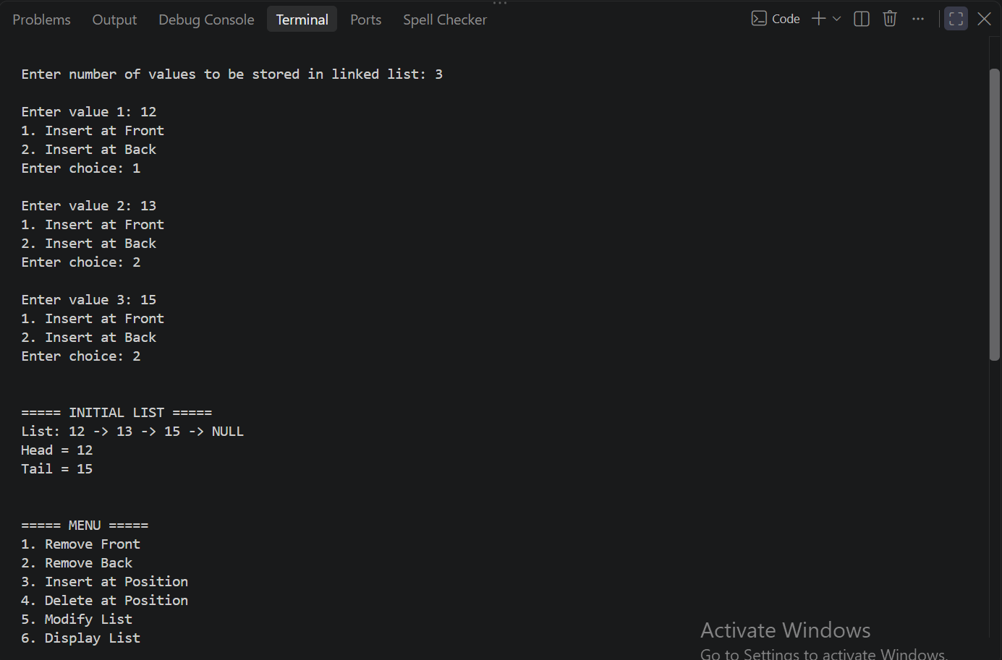
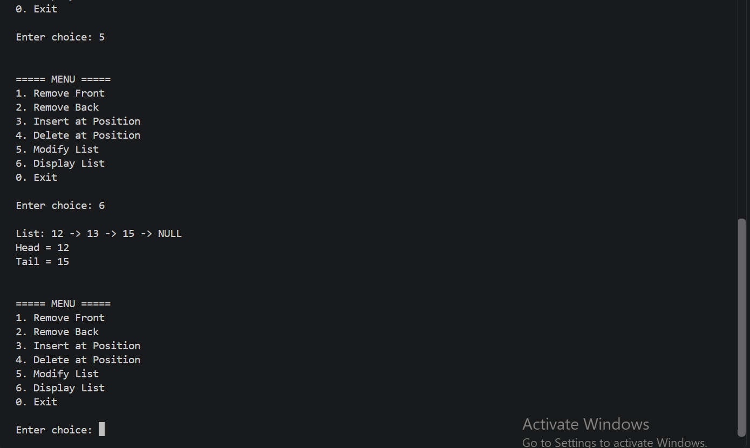

TASK 04:
#include <iostream>
using namespace std;

class Node
{
public:
int data;
Node *next;
Node *prev;

Node(int val)
{
data = val;
next = prev = nullptr;
}
};

class DLL
{
Node *head;
Node *tail;

public:
DLL()
{
head = tail = nullptr;
}

void insert(int val)
{
Node *newNode = new Node(val);

if (head == nullptr)
{
head = tail = newNode;

return;
}

tail->next = newNode;
newNode->prev = tail;
tail = newNode;
}

void deletePos(int val)
{
if (head == nullptr)
{
cout << "\nList is empty. ";
return;
}

Node *temp = head;

// Find the node
while (temp != nullptr && temp->data != val)
{
temp = temp->next;
}

// Value not found
if (temp == nullptr)
{
cout << "\nValue not found.";
return;
}

// Only one node
if (head == tail)
{
head = tail = nullptr;
}

// Delete head
else if (temp == head)
{
head = head->next;
head->prev = nullptr;
}

// Delete tail
else if (temp == tail)
{
tail = tail->prev;
tail->next = nullptr;
}

// Delete middle node
else
{
temp->prev->next = temp->next;
temp->next->prev = temp->prev;
}

delete temp;
}

void displayForward()
{
Node *temp = head;

cout << endl;

while (temp != nullptr)
{
cout << temp->data << "->";
temp = temp->next;
}
cout<<"NULL";
}

void displayBackword()
{
Node *temp = tail;

cout << endl;

cout<<"NULL<-";
while (temp != nullptr)
{
cout << temp->data << "<-";
temp = temp->prev;
}
}
};

int main()
{
DLL list;

int n;
cout << "Enter number of nodes: ";
cin >> n;

int val;

for (int i = 1; i <= n; i++)
{
cout << "Enter value " << i << ": ";
cin >> val;

list.insert(val);
}

cout << "\nOriginal list (Forward): ";
list.displayForward();

cout << "\nOriginal list (Backward): ";
list.displayBackword();

cout << "\n\nEnter value to delete: ";
cin >> val;

list.deletePos(val);

cout << "\nAfter deletion (Forward): ";
list.displayForward();

cout << "\nAfter deletion (Backward): ";
list.displayBackword();

return 0;
}
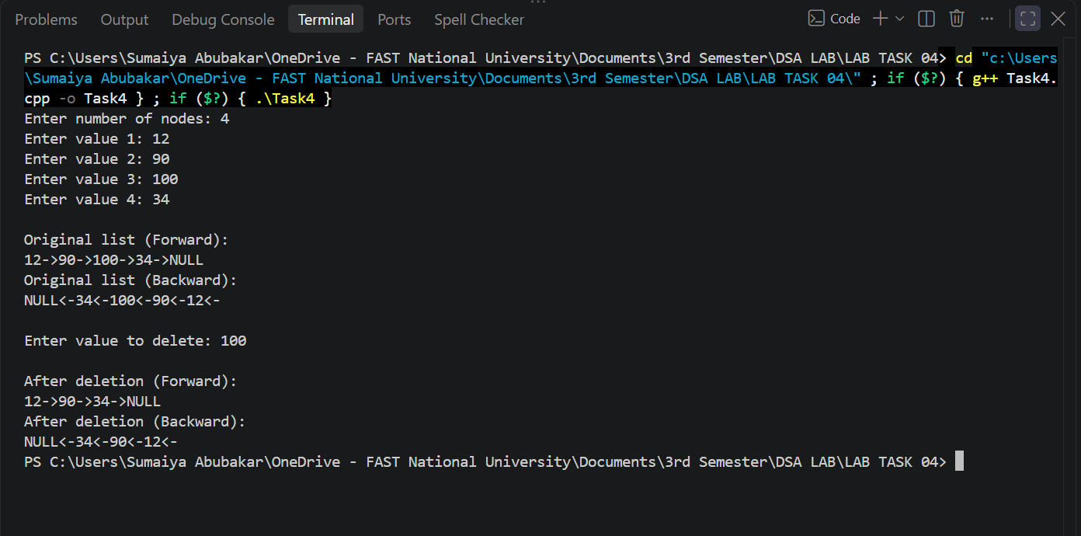

TASK 05:
#include <iostream>
using namespace std;

class Node
{
public:
int data;
Node *next;
Node *prev;

Node(int val)
{
data = val;
next = prev = nullptr;
}
};

class CDLL
{
Node *head;
Node *tail;

public:
CDLL()
{
head = tail = nullptr;
}

void insertAtHead(int val)
{
Node *newNode = new Node(val);

if (head == nullptr)
{
head = tail = newNode;
newNode->next = head;
newNode->prev = tail;
return;
}

newNode->next = head;
head->prev = newNode;

head = newNode;
tail->next = head;
head->prev = tail;
}

void insertAtTail(int val)
{
Node *newNode = new Node(val);

if (head == nullptr)
{
head = tail = newNode;
newNode->next = head;
newNode->prev = tail;
return;
}

tail->next = newNode;
newNode->prev = tail;
tail = newNode;
tail->next = head;
head->prev = tail;
}

void moveForward(int pos)
{
if (head == nullptr)
{
cout << "\nList is empty. ";
return;
}

if (pos < 1 || pos > getCount())
{
cout << "\nInvalid node. ";
return;
}

Node *temp = head;
for (int i = 1; i < pos; i++)
{
temp = temp->next;
}

cout << "\nNode at position " << pos << " : " << temp->data << endl;
}

int getCount()
{
int count = 0;
Node *temp = head;

if (head == nullptr)
{
return 0;
}

do
{
count++;
temp = temp->next;
} while (temp != head);

return count;
}
void moveBackward(int pos)
{
if (head == nullptr)
{
cout << "\nList is empty. ";
return;
}

if (pos < 1 || pos > getCount())
{
cout << "\nInvalid node. ";
return;
}

Node *temp = tail;
for (int i = getCount(); i > pos; i--)
{
temp = temp->prev;
}

cout << "\nNode at position " << pos << " : " << temp->data << endl;
}

void display()
{
Node *temp = head;
cout << "\n";

if (head == nullptr)
{
cout << "\nList is empty.";
return;
}
do
{
cout << temp->data << " -> ";
temp = temp->next;
}

while (temp != head);
}
};

int main()
{
CDLL list;

int n;
cout << "Enter number of nodes: ";
cin >> n;

int val;

for (int i = 1; i <= n; i++)
{
int val, choice;

cout << "\nEnter value " << i << ": ";
cin >> val;

cout << "1. Insert at Front";
cout << "\n2. Insert at Back";
cout << "\nEnter choice: ";
cin >> choice;

if (choice == 1)
{
list.insertAtHead(val);
}
else if (choice == 2)
{
list.insertAtTail(val);
}
else
{
cout << "Invalid choice. Value not inserted.\n";
i--;
}
}

cout << "\n\n===== INITIAL LIST =====";
list.display();

int choice;
int pos;

do
{
cout << "\n\n===== MENU =====";
cout << "\n1. Move forward";
cout << "\n2. Move backward";
cout << "\n0. Exit";

cout << "\n\nEnter choice: ";
cin >> choice;

if (choice == 1)
{
cout << "\nEnter position : ";
cin >> pos;
list.moveForward(pos);
cout << "\nAfter moving forward:";
list.display();
}

else if (choice == 2)
{
cout << "\nEnter position : ";
cin >> pos;
list.moveBackward(pos);
cout << "\nAfter moving back:";
list.display();
}

else if (choice == 0)
{
cout << "\nProgram ended.";
}

else
{
cout << "\nInvalid choice.";
}

} while (choice != 0);
}
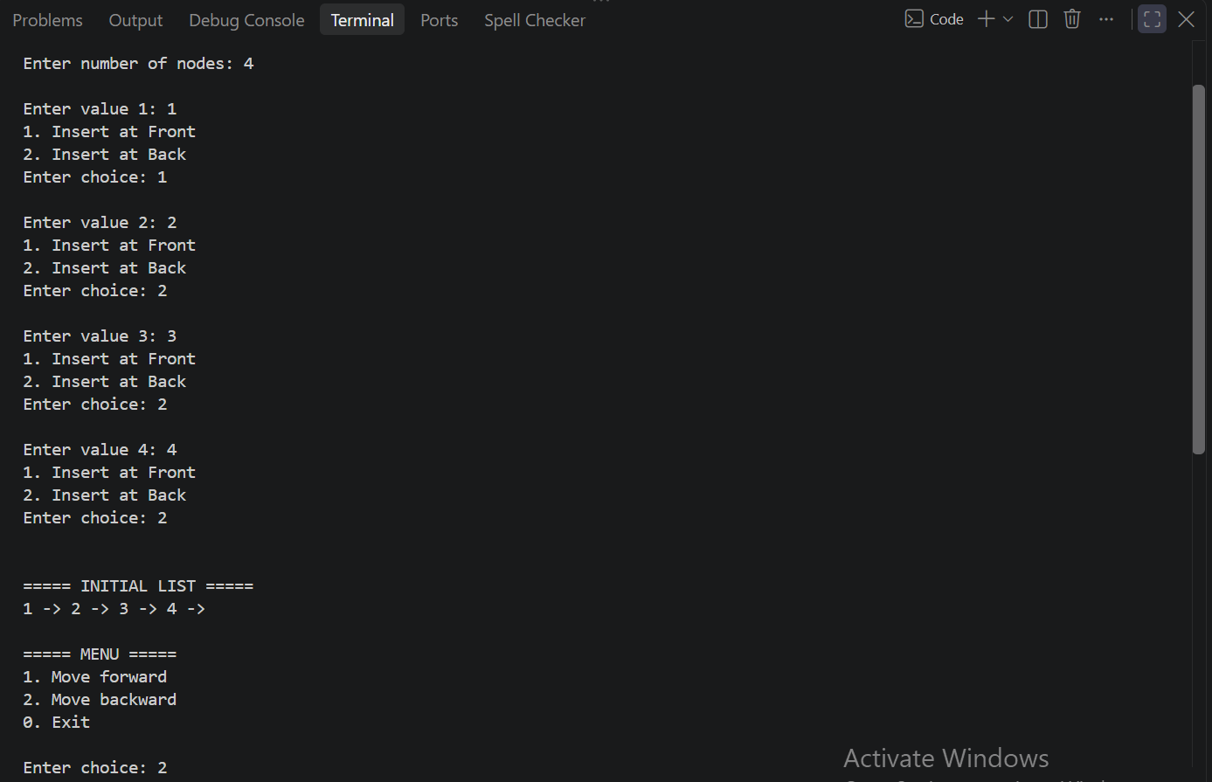
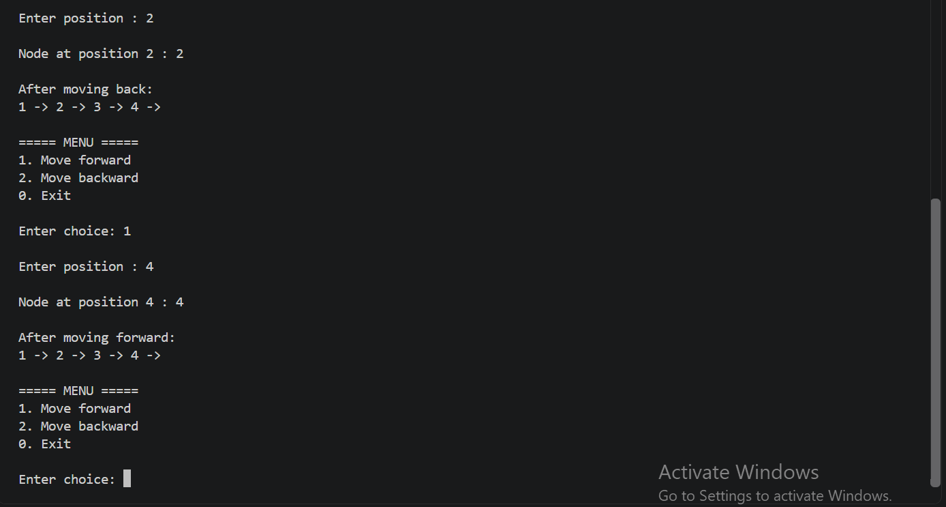

TASK 06:
#include <iostream>
using namespace std;

class Node
{
public:
string teamName;
int points;
Node *next;

Node(string name, int pts)
{
teamName = name;
points = pts;
next = nullptr;
}
};

class CSL
{
Node *head;
Node *tail;

public:
CSL()
{
head = tail = nullptr;
}

bool search(string name)
{
if (head == nullptr)
{
return false;
}

Node *temp = head;

do
{
if (temp->teamName == name)
{
return true;
}

temp = temp->next;
}

while (temp != head);

return false;
}

void addTeam(string name, int pts)
{
if (pts < 0 || pts > 150)
{
cout << "Invalid points. Points must be between 0 and 150.\n";
return;
}

if (search(name))
{
cout << "Duplicate team name. Team not added.\n";
return;
}

Node *newNode = new Node(name, pts);

if (head == nullptr)
{
head = tail = newNode;
newNode->next = head;
return;
}

tail->next = newNode;
tail = newNode;
tail->next = head;
}

void display()
{
if (head == nullptr)
{
cout << "List is empty.\n";
return;
}

Node *temp = head;

do
{
cout << temp->teamName << " - Points: " << temp->points << endl;

temp = temp->next;

} while (temp != head);
}

void removeTeam(string name)
{
if (head == nullptr)
{
cout << "\nList is empty.";
return;
}

Node *temp = head;
Node *prev = tail;

do
{
if (temp->teamName == name)
{
if (temp == head && temp == tail)
{
delete temp;
head = tail = nullptr;
cout << "\nTeam removed.\n";
return;
}

if (temp == head)
{
head = head->next;
tail->next = head;

delete temp;

cout << "\nTeam removed.\n";
return;
}

prev->next = temp->next;

if (temp == tail)
{
tail = prev;
tail->next = head;
}

delete temp;

cout << "Team removed.\n";
return;
}

prev = temp;
temp = temp->next;
}

while (temp != head);

cout << "\nTeam not found.";
}

Node *findHighestScoreTeam()
{
if (head == nullptr)
{
return nullptr;
}

Node *highest = head;
Node *temp = head->next;

while (temp != head)
{
if (temp->points > highest->points)
{
highest = temp;
}

temp = temp->next;
}

return highest;
}

Node *findLowestScoreTeam()
{
if (head == nullptr)
{
return nullptr;
}

Node *Lowest = head;
Node *temp = head->next;

while (temp != head)
{
if (temp->points < Lowest->points)
{
Lowest = temp;
}

temp = temp->next;
}

return Lowest;
}

void updatePoints()
{
if (head == nullptr)
{
return;
}

Node *temp = head;

int position = 1;

do
{
if (position % 2 == 1)
{
temp->points = temp->points - 20;
}
else
{
temp->points = temp->points + 10;
}

if (temp->points < 0)
{
temp->points = 0;
}

if (temp->points > 150)
{
temp->points = 150;
}

temp = temp->next;
position++;
}

while (temp != head);
}

Node *findLowestFrom(Node *start)
{
Node *lowest = start;
Node *temp = start->next;

do
{
if (temp->points < lowest->points)
{
lowest = temp;
}

temp = temp->next;

}

while (temp != start);

return lowest;
}

void knockOutChallenge()
{
if (head == nullptr)
{
cout << "No teams available.\n";
return;
}

if (head == tail)
{
cout << "Only one team exists.\n";
cout << "Champion: " << head->teamName << endl;
return;
}

string startTeam;
int count;

cout << "Enter starting team: ";
cin >> startTeam;

cout << "Enter counting number: ";
cin >> count;

if (count <= 0)
{
cout << "Counting number must be greater than 0.\n";
return;
}

Node *current = head;
bool found = false;

do
{
if (current->teamName == startTeam)
{
found = true;
break;
}

current = current->next;

} while (current != head);

if (!found)
{
cout << "Starting team not found.\n";
return;
}

while (head != tail)
{
Node *selected = current;

for (int i = 1; i < count; i++)
{
selected = selected->next;
}

Node *prev = selected;

while (prev->next != selected)
{
prev = prev->next;
}

Node *highest = findHighestScoreTeam();

Node *eliminated;
Node *eliminatedPrev;

if (selected->points == highest->points)
{
cout << "Selected team " << selected->teamName
<< " cannot be eliminated because it has the highest points.\n";
eliminated = findLowestFrom(current);

eliminatedPrev = eliminated;

while (eliminatedPrev->next != eliminated)
{
eliminatedPrev = eliminatedPrev->next;
}
}
else
{
eliminated = selected;
eliminatedPrev = prev;
}

Node *nextStart = eliminated->next;

eliminatedPrev->next = eliminated->next;

if (eliminated == head)
{
head = eliminated->next;
}

if (eliminated == tail)
{
tail = eliminatedPrev;
}

tail->next = head;

cout << "Eliminated team: " << eliminated->teamName << endl;

delete eliminated;

current = nextStart;

updatePoints();

display();
}

cout << "\nFIFA Knockout Challenge Champion: " << head->teamName << endl;
}
};

int main()
{
CSL list;

int choice;

do
{
cout << "\n===== FIFA WORLD CUP KNOCKOUT CHALLENGE =====\n";
cout << "1. Add Team\n";
cout << "2. Remove Team\n";
cout << "3. Search Team\n";
cout << "4. Display Teams\n";
cout << "5. Start Knockout Challenge\n";
cout << "6. Exit\n";

cout << "Enter your choice: ";
cin >> choice;

if (choice == 1)
{
string name;
int points;

cout << "Enter team name: ";
cin >> name;

cout << "Enter points: ";
cin >> points;

list.addTeam(name, points);
}

else if (choice == 2)
{
string name;

cout << "Enter team name to remove: ";
cin >> name;

list.removeTeam(name);
}

else if (choice == 3)
{
string name;

cout << "Enter team name to search: ";
cin >> name;

if (list.search(name))
{
cout << "Team found.\n";
}
else
{
cout << "Team not found.\n";
}
}

else if (choice == 4)
{
list.display();
}

else if (choice == 5)
{
list.knockOutChallenge();
}

else if (choice == 6)
{
cout << "Program ended.\n";
}

else
{
cout << "Invalid choice.\n";
}

} while (choice != 6);

return 0;
}
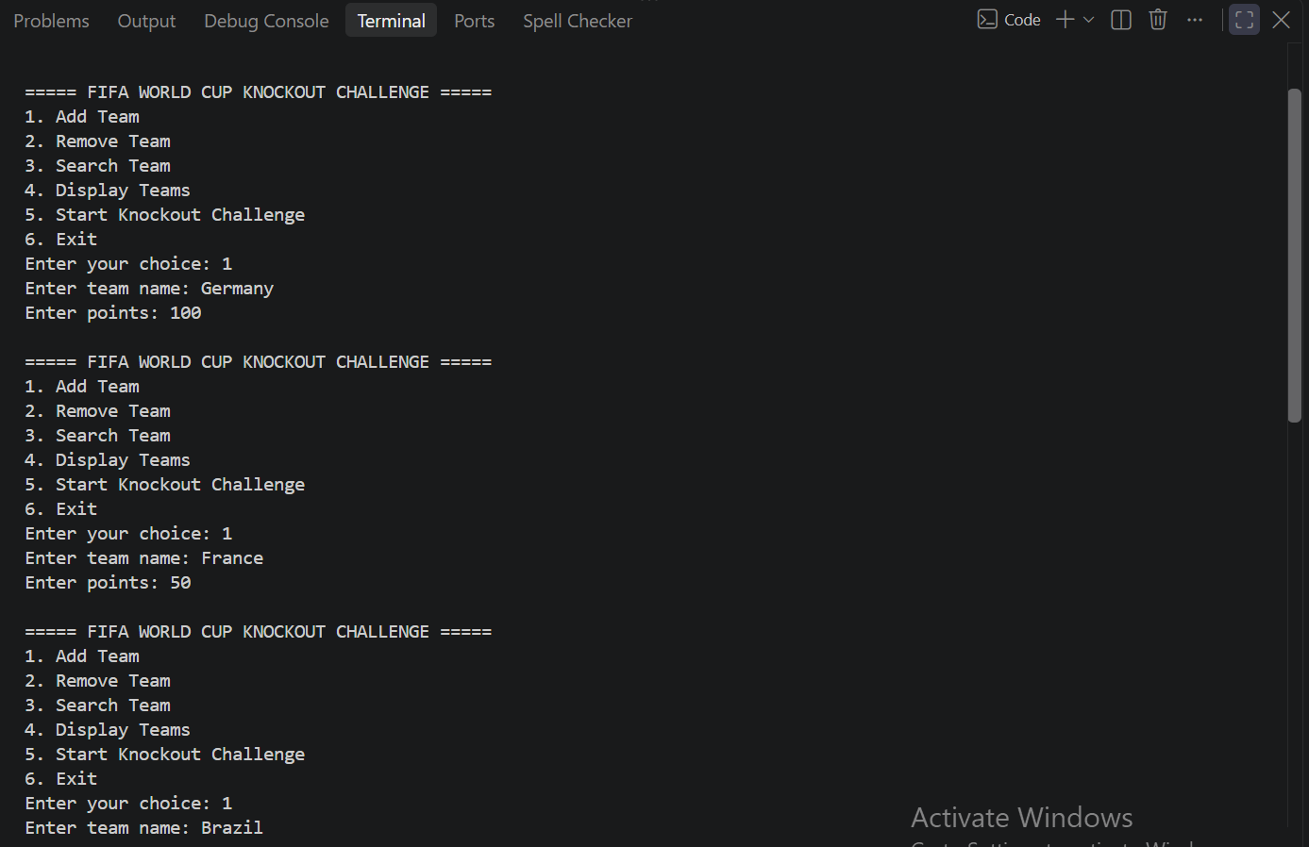
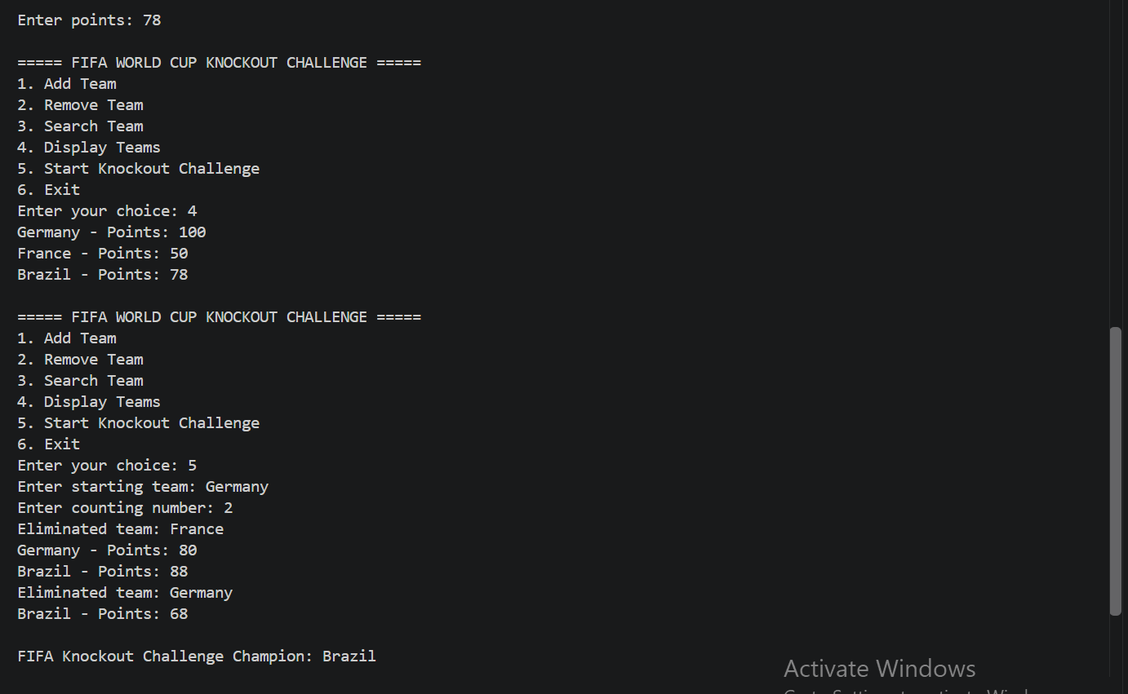

TASK 07:
#include <iostream>
using namespace std;

class Node
{
public:
string teamName;
int points;
Node *next;
Node *prev;

Node(string name, int pts)
{
teamName = name;
points = pts;
next = nullptr;
prev = nullptr;
}
};

class CSL
{
Node *head;
Node *tail;

public:
CSL()
{
head = tail = nullptr;
}

bool search(string name)
{
if (head == nullptr)
{
return false;
}

Node *temp = head;

do
{
if (temp->teamName == name)
{
return true;
}

temp = temp->next;
}

while (temp != head);

return false;
}

void addTeam(string name, int pts)
{
if (pts < 0 || pts > 150)
{
cout << "Invalid points. Points must be between 0 and 150.\n";
return;
}

if (search(name))
{
cout << "Duplicate team name. Team not added.\n";
return;
}

Node *newNode = new Node(name, pts);

if (head == nullptr)
{
head = tail = newNode;
newNode->next = head;
newNode->prev = tail;
return;
}

tail->next = newNode;
newNode->prev = tail;
tail = newNode;
tail->next = head;
head->prev = tail;
}

void display()
{
if (head == nullptr)
{
cout << "List is empty.\n";
return;
}

Node *temp = head;

do
{
cout << temp->teamName << " - Points: " << temp->points << endl;

temp = temp->next;

} while (temp != head);
}

void removeTeam(string name)
{
if (head == nullptr)
{
cout << "\nList is empty.";
return;
}

Node *temp = head;

do
{
if (temp->teamName == name)
{
if (temp == head && temp == tail)
{
delete temp;
head = tail = nullptr;
cout << "\nTeam removed.\n";
return;
}

temp->prev->next = temp->next;
temp->next->prev = temp->prev;

if (temp == head)
{
head = temp->next;
}

if (temp == tail)
{
tail = temp->prev;
}

tail->next = head;
head->prev = tail;

delete temp;

cout << "Team removed.\n";
return;
}

temp = temp->next;
}

while (temp != head);

cout << "\nTeam not found.";
}

Node *findHighestScoreTeam()
{
if (head == nullptr)
{
return nullptr;
}

Node *highest = head;
Node *temp = head->next;

while (temp != head)
{
if (temp->points > highest->points)
{
highest = temp;
}

temp = temp->next;
}

return highest;
}

Node *findLowestScoreTeam()
{
if (head == nullptr)
{
return nullptr;
}

Node *Lowest = head;
Node *temp = head->next;

while (temp != head)
{
if (temp->points < Lowest->points)
{
Lowest = temp;
}

temp = temp->next;
}

return Lowest;
}

void updatePoints()
{
if (head == nullptr)
{
return;
}

Node *temp = head;

int position = 1;

do
{
if (position % 2 == 1)
{
temp->points = temp->points - 20;
}
else
{
temp->points = temp->points + 10;
}

if (temp->points < 0)
{
temp->points = 0;
}

if (temp->points > 150)
{
temp->points = 150;
}

temp = temp->next;
position++;
}

while (temp != head);
}

// Node *findLowestFrom(Node *start)
// {
// Node *lowest = start;
// Node *temp = start->next;

// do
// {
// if (temp->points < lowest->points)
// {
// lowest = temp;
// }

// temp = temp->next;

// }

// while (temp != start);

// return lowest;
// }

void knockOutChallenge()
{
if (head == nullptr)
{
cout << "No teams available.\n";
return;
}

if (head == tail)
{
cout << "Only one team exists.\n";
cout << "Champion: " << head->teamName << endl;
return;
}

string startTeam;
int count;

cout << "Enter starting team: ";
cin >> startTeam;

cout << "Enter counting number: ";
cin >> count;

if (count <= 0)
{
cout << "Counting number must be greater than 0.\n";
return;
}

Node *current = head;
bool found = false;

do
{
if (current->teamName == startTeam)
{
found = true;
break;
}

current = current->next;

} while (current != head);

if (!found)
{
cout << "Starting team not found.\n";
return;
}

bool forward = true;

while (head != tail)
{
Node *selected = current;

for (int i = 1; i < count; i++)
{
if (forward)
{
selected = selected->next;
}
else
{
selected = selected->prev;
}
}

Node *highest = findHighestScoreTeam();

Node *eliminated;

bool protectionTriggered = false;

if (selected->points == highest->points)
{
cout << "Selected team " << selected->teamName
<< " cannot be eliminated because it has the highest points.\n";
eliminated = findLowestScoreTeam();
protectionTriggered = true;
}
else
{
eliminated = selected;
}

Node *nextForward = eliminated->next;
Node *nextBackward = eliminated->prev;

eliminated->prev->next = eliminated->next;
eliminated->next->prev = eliminated->prev;

// Node *nextStart = eliminated->next;

// eliminatedPrev->next = eliminated->next;

if (eliminated == head)
{
head = eliminated->next;
}

if (eliminated == tail)
{
tail = eliminated->prev;
}

tail->next = head;
head->prev = tail;

cout << "Eliminated team: " << eliminated->teamName << endl;

delete eliminated;

if (protectionTriggered)
{
forward = !forward;
}

if (forward)
{
current = nextForward;
}
else
{
current = nextBackward;
}

// current = nextStart;

updatePoints();

display();
}

cout << "\nFIFA Knockout Challenge Champion: " << head->teamName << endl;
}
};

int main()
{
CSL list;

int choice;

do
{
cout << "\n===== FIFA WORLD CUP KNOCKOUT CHALLENGE =====\n";
cout << "1. Add Team\n";
cout << "2. Remove Team\n";
cout << "3. Search Team\n";
cout << "4. Display Teams\n";
cout << "5. Start Knockout Challenge\n";
cout << "6. Exit\n";

cout << "Enter your choice: ";
cin >> choice;

if (choice == 1)
{
string name;
int points;

cout << "Enter team name: ";
cin >> name;

cout << "Enter points: ";
cin >> points;

list.addTeam(name, points);
}

else if (choice == 2)
{
string name;

cout << "Enter team name to remove: ";
cin >> name;

list.removeTeam(name);
}

else if (choice == 3)
{
string name;

cout << "Enter team name to search: ";
cin >> name;

if (list.search(name))
{
cout << "Team found.\n";
}
else
{
cout << "Team not found.\n";
}
}

else if (choice == 4)
{
list.display();
}

else if (choice == 5)
{
list.knockOutChallenge();
}

else if (choice == 6)
{
cout << "Program ended.\n";
}

else
{
cout << "Invalid choice.\n";
}

} while (choice != 6);

return 0;
}
